**UNIT 2**

**Computer Architecture**



Picture 2.1

**Learning Outcomes**:

By the end of the lesson, the students are expected to be able to use appropriate English to:

▪ identify and describe kinds of computer

▪ read a computer advertisement

▪ identify parts of computer

▪ describe functions of parts of computer

▪ identify comparatives and superlatives

▪ identify phrases used for presentation

▪ perform a presentation using phrases explained

▪ compare and contrast computers and any other devices using comparative and superlatives

**2.1. Reading a computer advertisement**

**Exercise 1:** You are going to listen to an extract from an ICT class about **five** types of computer.

As you listen, identify the pictures (a-e) with words from the box.

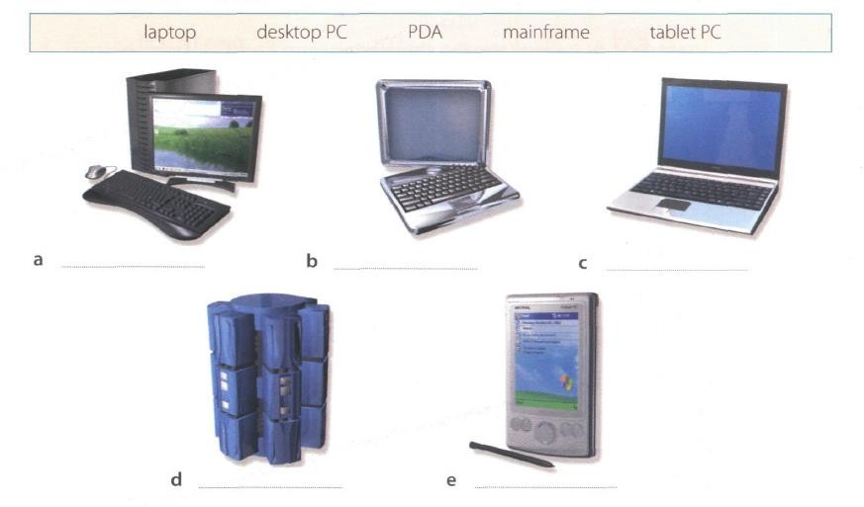

Picture 2.2

Answer

A = desktop PC

B = tablet PC

C = laptop

D = mainframe

E = PDA

**Exercise 2**: Listen again and decide whether these sentences are true or false. Correct the false ones.

1. A mainframe computer is less powerful than a PC. (T/F) F

Because mainframe are the largest and powefull computers

2. A mainframe is used by large organizations that need to process enormous amounts of data. (T/F) T

3. The most suitable computers for home use are desktop PC. (T/F) T

4. A laptop is not portable. (T/F) F

Because a laptop is a portable computer that has a flat LCD sceen.

5. Laptops are not as powerful as desktop PCs. (T/F) T

6. Using a stylus, you can write directly onto the screen of a tablet PC. (T/F) T

7. A Personal Digital Assistant is small enough to fit into the palm of your hand. (T/F) T

8. A PDA does not allow you to surf the Web. (T/F) F

Because PDA can access the internet via wi-fi network

**Exercise 3**: Match these names to the different types of computer.

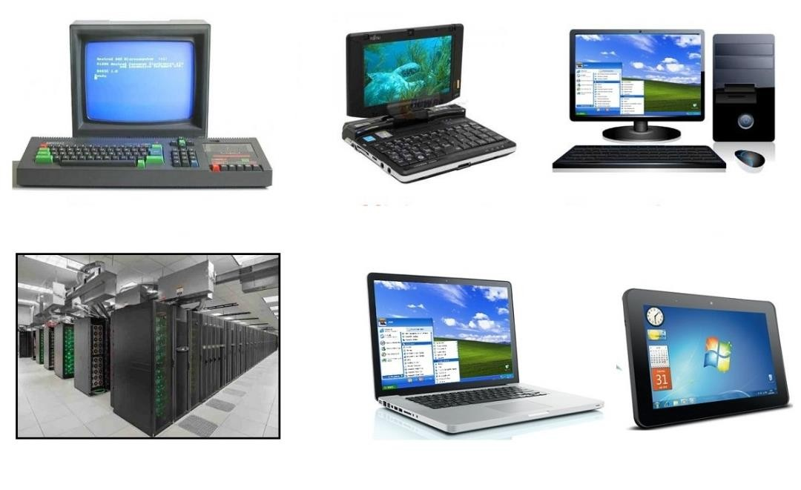

Picture 2.3

|  |  |  |
| --- | --- | --- |
| 1. minicomputer | 3. tablet | 5. PC |
| 2. laptop | 4. microcomputer | 6. supercomputer/mainframe |

**Exercise 4**: Listen to Part 1 of the conversation between a shop assistant and a customer. Tick

(√) the correct answers to the questions below.

1. The customer wants a computer for......

writing internet games

graphics video

2. A multimedia computer provides......

sound telephone

graphics video

games

**Exercise 5:** Listen to Part 2 of the conversation. In column A, tick hardware items named. In

column B, tick the items the assistant recommends.

|  |  |  |  |  |  |
| --- | --- | --- | --- | --- | --- |
| **A** | **B** | **Device** | **A** | **B** | **Device** |
|  |  | multimedia computer |  |  | handheld |
|  |  | multimedia notebook |  |  | printer |
|  |  | subnotebook |  |  | monitor |
|  |  | laptop |  |  | Modem |

**Exercise 6**: Study the text entitled ”How to Read a Computer Ad” and then answer the following

questions.

1. What is the memory size of PC?

16 GB dual channel DDR4 SDRAM

1. What storage devices are supplied?

512 SSD & 2 TB Serial ATA hard drive (7200 r.p.m)

1. What size is the display screen?

42” TFT flat panel 4K (3840 x 2160) monitor

1. How fast is the processor?

800 MHz

1. What is the capacity of the hard drive?

512 SSD & 2 TB Serial ATA hard drive (7200 r.p.m)

1. Which operating system does it use?

Microsoft Windows 10 Professional

7. What multimedia features does the computer have?

Integrated Dolby Atmos Stereo audio

Answer

Exercise 6

1. 16 GB dual channel of memory RAM

2. 512 SSD & 2TB of SATA HDD

3. 42” inch 4K resolution

4. Base clock of 3.6 GHz, with Bus speed of 800 MHz

5. 2 TB

6. Microsoft Windows 10 Pro

7. Dolby Atmos Stereo Audio

**HOW TO READ A COMPUTER AD.**

**1** Intel Core i7-9700K 9th Generation (Coffee lake). Base Clock: 3.6 GHz, Bus Speed: 800 MHz

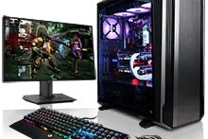

**2** Mini-tower chassis

**3** 16 GB dual channel DDR4 SDRAM

**4** 512 SSD & 2 TB Serial ATA hard drive (7200 r.p.m)

**5** 8 GB GDDR6 NVIDIA PCI-Express

video graphic card

**6** Integrated Dolby Atmos Stereo audio

**7** Corsair K95 RGB Platinum Keyboard

**8** 42” TFT flat panel 4K (3840 x 2160)

monitor

**9** Microsoft Windows 10 Professional

Picture 2.4

|  |  |  |  |  |  |
| --- | --- | --- | --- | --- | --- |
| 1 | The main processing chip called a ‘core i7’ that was designed and manufactured by the intel Corporation. It operates at | 4 | A Solid-state drive with a  512 gigabytes storage and a hard drive with a capacity of two terabytes that uses a type of | 6 | Electronics for controlling the sound output that is built into the main electronics of the computer. |
|  | a clock speed of three- |  | connection interface | 7 | The K95 Platinum is a big |
|  | point six gigahertz and has |  | known as Serial ATA. It has |  | keyboard. Dedicated |
|  | a front-side bus that |  | a serial data connection |  | media controls and a USB |
|  | operates at a speed of |  | rather than the original |  | pass-through, a metal |
| 2 | eight hundred megahertz.  A small, tall and narrow |  | parallel connection. It  rotates at a speed of seven |  | volume wheel, RGB  lighting. It even comes |
|  | style of case containing |  | thousand, two hundred |  | with an extra set of |
| 3 | the computer system.  Synchronous dynamic | 5 | revolutions per minute.  Electronics for driving the |  | textured keycaps for the  WASD keys. |
|  | random-access memory |  | graphics output that has a | 8 | A forty-two inch, flat |
|  | with a capacity of sixteen |  | memory capacity of eight |  | display screen made from |
|  | gigabyte. It is a high |  | gigabytes and uses a type |  | thin film transistors with a |
|  | bandwidth, double data |  | of connection interface |  | resolution of 3840 by |
|  | rate memory. |  | known as PCI-Express. | 9 | 2160.  The operating system that |
|  |  |  |  |  | is used to control the |
|  |  |  |  |  | system. |

*Oxford English for Information Technology (2011: 11)*

**2.2. Describing functions of computer**

We can describe the function of an item in a number of ways. Study these examples.

**Using the present simple**

1. ROM  *holds* instruction which are needed to start up the computer.

***Used to-*infinitive, *Used for + -ing***

**form**

2. ROM is  *used* to *hold* instructions which are needed to start up the computer.

3. ROM is *used for holding* instructions which are needed to start up the computer.

**Emphasizing the function**

4. *The function of ROM is* to hold instruction which are needed to start up the computer.

**Exercise 7**: Match each item with its functions. Then describe the functions in three ways as the

examples on the table above.

|  |  |
| --- | --- |
| **Items** | **Functions** |
| 1. RAM | A. controls the cursor |
| 2. processor | B. inputs data through keys like a |
| 3. mouse | typewriter |
| 4. clock | C. displays the output from a |
| 5. flash memory key  6. monitor  7. keyboard  8. cache  9. DVD-ROM drive  10. ROM | computer on a screen  D. reads DVD-ROMs  E. reads and writes to electronic chips on a card  F. holds instructions which are needed to start up the computer  G. holds data read or written to it by the processor  H. provides extremely fast access for sections of a program and its data  I. controls the timing of signals in the computer  J. controls all the operations in a computer |

**Exercise 8**: With your partner, describe the functions of these items using the forms you have

learned before.

1. Scanner

2. printer

3. CPU

4. SSD

5. hard disk driver

6. ports

7. mainframe computer

8. barcodes

9. swipe cards

10. main memory

**2.3. Comparing and contrasting computer**

**Exercise 9:** Study these details of different types of computer. Find answers to the questions.

Which computer is?

1. The most common?

2. Small enough for a pocket?

3. The most common portable?

4. Used by many people at the same time?

5. Used like mainframes?

6. Also called a handheld computer?

7. The most powerful?

8. Not suitable for a lot typing?

**Types of Computer Notes**

**Mainframes** Large, powerful, expensive.

Multi-user systems – used by many people at the same time.

Used for processing very large amounts of data. The most powerful mainframes are called *supercomputers.*

**Minicomputers** Used like mainframes.

Not as big, powerful, or expensive as mainframes. Less common now because microcomputers have improved.

**Microcomputers or**

**Personal computers (PCs)**

The most common type of computer.

Smaller, cheaper, and less powerful than mainframes and minicomputers.

**Types of Portable Notes**

**Laptop** About the size of small typewriter.

Less common now because smaller and lighter portables are available.

**Notebook** About the size of a piece of writing paper.

The most common type of portable.

**Subnotebook** Not quite as big as notebooks. Can fit into a jacket pocket.

**Handheld or**

**Palmtop**

Small enough to fit into the palm of one hand. Not easy to type with because of their size.

Specialized handheld computer known as PDAs are used as personal organizers.

**Exercise 10:** Study this comparison of three types of computer.

|  |  |  |  |
| --- | --- | --- | --- |
|  | **Mainframes** | **Minicomputers** | **Microcomputers** |
| **Size**  **Power**  **Cost** | **+++**  **+++**  **+++** | **++**  **++**  **++** | **+**  **+**  **+** |

We compare things using adjectives in two ways.

1. We can compare one type of computer with another.

*Minicomputers are* ***bigger than*** *microcomputers. Mainframes are* ***more expensive than*** *microcomputers.* For negative comparisons, we can say:

*Microcomputers are* ***not as big as*** *minicomputers. Microcomputers are* ***not as powerful as*** *mainframes.*

2. We can compare mainframes to all other types of computer.

*Mainframes are* ***the biggest*** *computers. Mainframes are* ***the most powerful*** *computers. Mainframes are* ***the most expensive*** *computers.*

With short adjectives (big*, small, fast*), we add *–er* and *–est* (*faster, fastest*). With longer adjectives (*powerful, expensive*), we use *more/less* and the *most/ the least* before the adjectives (*more powerful, the most powerful)*. Remember some exceptions:

*good – better – the best bad – worse – the worst*

**Exercise 11:** Choose the correct adjectives. Then fill in the gaps with the correct form of the

adjectives.

***light/heavy***

Laptops are **1** than desktop computers, but

**2** than notebooks.

***large/small***

The mainframes is the **3**

type of

computer. A minicomputer is **4**

than a

microcomputer.

***common/good***

Personal computer are **5**

than

mainframes but mainframes are **6** than

personal computers at processing very large amounts of

***powerful/expensive***

***fast/cheap***

data.

Minicomputers are **7** than mainframes but they are also **8**

New computers are **9**

and sometimes

***powerful/expensive***

**10** than older machines.

Laptops are often 11 than PCs but they are not as **12**

**Exercise 12**: Put the words in brackets into the correct form.

There are different types of computer. The (*large*) **1**

and (powerful)

**2** are mainframe computers. Minicomputers are (small)

**3** than mainframes but are still very powerful. Microcomputers are small enough to sit on a desk. They are the (common) **4** type of computer.

They are usually (powerful) **5** than microcomputers.

Portable computers are (small) **6**

than desktops. The (large)

**7** portable is a laptop. (Small) **8** portables, about the size of

a piece of writing paper, are called notebook computers. Subnotebooks are (small)

**9** than notebooks. You can hold the (small) **10**

computers in one hand. They are called handheld computers or palmtop computers.

**Exercise 13**: In pairs, discuss who or what you think is:

1. The most difficult game you’ve ever played.

2. The most exciting film you’ve ever seen.

3. The funniest program on TV.

4. The most dangerous computer virus.

5. The best blogger or webmaster on the web.

6. The most popular web browser.

**Exercise 14**: Preparation is essential for an effective presentation. Here are some phrases that

can help you delivering a better presentation.

**Useful Phrases for Presentation**

When giving a presentation, certain keywords are used to signpost the different stages. It’s a good idea to memories them and practice them so that they come to your mind easily during a presentation.

|  |  |
| --- | --- |
| **Useful Phrases for Presentation** | |
| **Starting the presentation** | **Explaining the purpose** |
| ● Good morning/good afternoon ladies and  gentlemen.  ● The subject of my presentation today is …  ● What I’m going to talk about today is … | ● The purpose of this presentation is …  ● My objective is to …  ● My main aim today is to … |
| **Stating the main points** | **Introducing the first point** |
| ● The main points I will be talking about | ● Let’s start/begin with …  ● I’d like to start by …. |
| today are firstly …, secondly …., next …., |
| finally, we’re going to look at… |
| **Showing visuals** | **Moving on to the next point** |
| ● I’d like to illustrate this by showing you … | ● Now let’s move on to … |
| **Referring to an earlier point** | **Summarizing** |
| ● Let me go back to what I said earlier about | ● I’d like to recap the main points of my  presentation. First I covered …, then we talked about … and finally we looked at …  ● I’d now like to sum up the main points, which were … |
| … |

|  |  |
| --- | --- |
| **Conclusion Inviting** | **Questions** |
| ● I’m going to conclude by … saying that /  inviting you to / quoting …  ● In conclusion, let me leave you with this  thought / invite you to … | ● Finally, I’ll be happy to answer your  questions.  ● Now I’d like to invite any questions you  might have.  ● Do you have any questions? |

**Exercise 15**: Now put the following phrases in the correct groups. Add some more phrases that

you know.

● In conclusion, let me leave you with this thought / invite you to …

● Good morning/good afternoon ladies and gentlemen.

● The main points I will be talking about today are firstly …, secondly …., next …., finally, we’re going to look at…

● I’m going to conclude by … saying that / inviting you to / quoting …

● Now let’s move on to …

● My objective is to …

● Finally, I’ll be happy to answer your questions.

● Now I’d like to invite any questions you might have.

● What I’m going to talk about today is …

● The subject of my presentation today is …

● I’d like to illustrate this by showing you …

● I’d like to recap the main points of my presentation. First I covered …, then we talked about

… and finally we looked at …

|  |  |
| --- | --- |
| Useful Phrases for Presentation | |
| **Starting the presentation** | **Explaining the purpose** |
|  |  |
| **Stating the main points** | **Introducing the first point** |
|  |  |
| **Showing visuals** | **Moving on to the next point** |
|  |  |
| **Referring to an earlier point** | **Summarizing** |
|  |  |
| **Conclusion** | **Inviting Questions** |
|  |  |

**Page | 25**

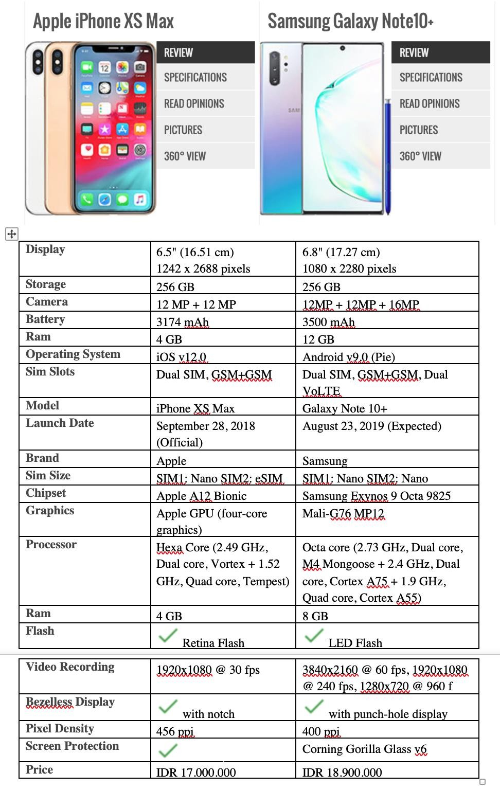

Picture 2.5

**Exercise 16**: In pairs, find two different advertisements of PCs/laptops/any gadgets and write some comparisons (at least 10 sentences) based on their specifications and present it in the class. Use the phrases that you have learned today.

**Look at the example below.**

**Example of Writing a Comparison between Two Things**

1. Samsung Galaxy Note 10+’s size is bigger than iPhone XS Max’s.

2. The storage of Samsung Galaxy Note 10+ and iPhone XS Max has the same capacity.

3. The price of Samsung Galaxy Note 10+ is more expensive than iPhone XS Max.

4. …..

5. …..